SMART ENERGY METER

CONNECTION:

ZMPT101B Pin | Connects To (ESP32) | Purpose
VCC | 5V | Power supply to voltage sensor
GND | GND | Common ground
OUT | GPIO34 (ADC1_CH6) | AC voltage analog reading

ACS712 Pin | Connects To (ESP32) | Purpose
VCC | 5V | Power supply to ACS712
GND | GND | Common ground
OUT | GPIO35 (ADC1_CH7) | AC current analog reading
IP+ (Terminal) | LIVE wire input from mains | Current flowing into sensor
IP− (Terminal) | LIVE wire output to load | Current flowing out to the load

Relay Pin | Connects To (ESP32) | Purpose
VCC | 5V | Relay power supply
GND | GND | Common ground
IN | GPIO2 | Control signal from ESP32
COM (Load side) | MAIN Live input | Switching live wire
NO/NC | Live output to load | Load control

Component | Connects To | Purpose
ESP32 5V pin | Sensor modules | Power to sensors
All GND pins | Common together | Shared reference ground
USB cable | ESP32 power | For programming & testing

AC Component | Connection | Explanation
AC Live (Phase) | goes through ACS712 IP+ → IP− | Allows current measurement
AC Neutral | goes directly to load | Do not pass neutral through ACS712
AC Live Branch | Connected to ZMPT101B terminal block | Voltage measurement
Relay (optional) | Connected in series with Live | For overload cut-off

ROUGH DIAGRAM:
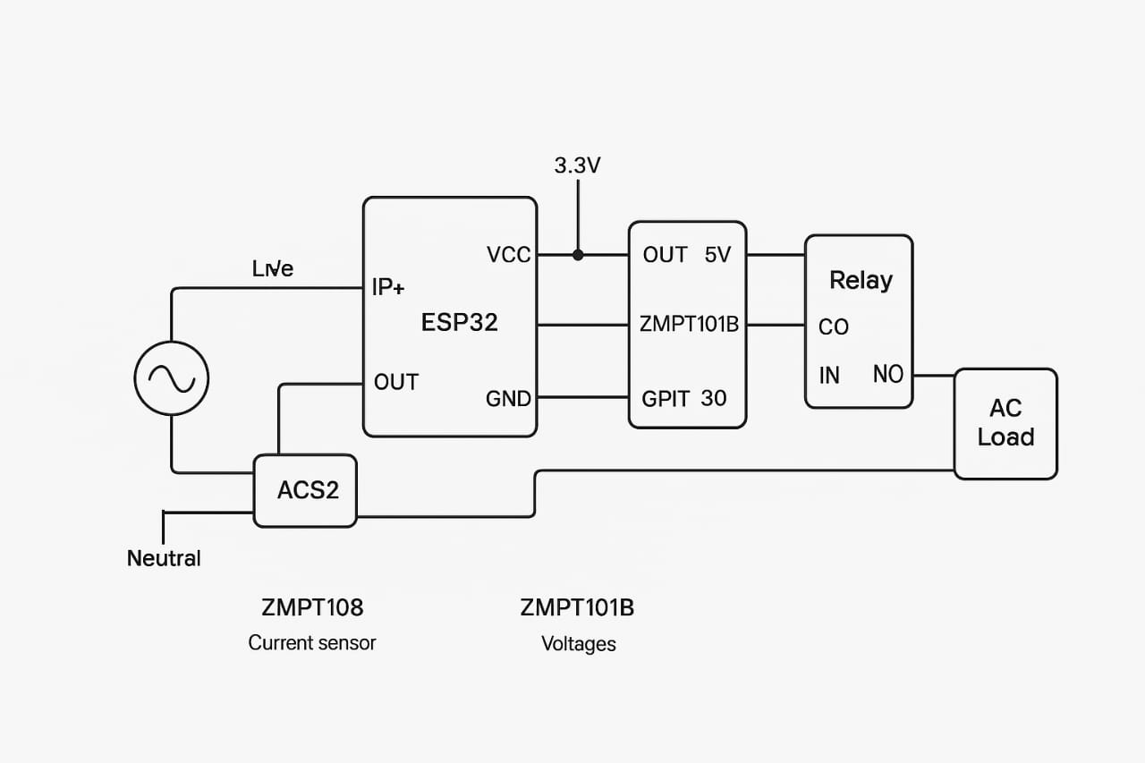

CODE:
const char* WIFI_SSID = "YOUR_SSID";
const char* WIFI_PASS = "YOUR_PASS";
const char* THINGSPEAK_API_KEY = "YOUR_THINGSPEAK_WRITE_KEY"; // optional, leave "" to disable upload
const bool ENABLE_THINGSPEAK = false; // set true to upload

// Pins
const int V_SENSOR_PIN = 34; // ZMPT101B analog out
const int I_SENSOR_PIN = 35; // ACS712 analog out
const int RELAY_PIN = 2; // optional relay

// Sampling and calibration
const unsigned int NUM_SAMPLES = 2000; // number of ADC samples per measurement window
const unsigned long SAMPLE_INTERVAL_US = 500; // microseconds between samples -> ~2kHz sampling

// ADC reference / conversion (ESP32 ADC characteristics)
const float ADC_REF_VOLTAGE = 3.3; // approximate
const int ADC_MAX = 4095; // 12-bit ADC on ESP32 default

// Sensor calibration (set and tune)
float V_CAL = 110.0 / 0.5; // placeholder - we'll calibrate. (example: adjust after initial test)
float I_CAL = 1.0; // multiply measured current by this factor after calibration

// For ACS712: sensitivity e.g., 185 mV/A for 5A version; if you use ACS712, calibrate in code
// But because ADC scaling & circuit specifics vary, calibrate using known loads.

// Global accumulators
double energy_wh = 0.0; // watt-hours
unsigned long lastEnergyMillis = 0;

// Helper: read analog and convert to voltage
inline float readADCVoltage(int pin) {
int raw = analogRead(pin);
return (raw * ADC_REF_VOLTAGE) / ADC_MAX;
}

void setup() {
Serial.begin(115200);
delay(1000);
pinMode(RELAY_PIN, OUTPUT);
digitalWrite(RELAY_PIN, LOW); // relay OFF by default (change as needed)

// optionally connect wifi if uploading
if (ENABLE_THINGSPEAK && strlen(WIFI_SSID) > 0) {
Serial.print("Connecting to WiFi...");
WiFi.begin(WIFI_SSID, WIFI_PASS);
unsigned long start = millis();
while (WiFi.status() != WL_CONNECTED && millis() - start < 10000) {
delay(200);
Serial.print(".");
}
Serial.println();
if (WiFi.status() == WL_CONNECTED) {
Serial.print("WiFi connected, IP: ");
Serial.println(WiFi.localIP());
} else {
Serial.println("WiFi failed to connect.");
}
}
lastEnergyMillis = millis();
}

void loop() {
// Sample loop
double sumV2 = 0.0;
double sumI2 = 0.0;
double sumP = 0.0;
unsigned int sampleCount = NUM_SAMPLES;

// For offset removal, take midpoints
// For ACS712: midpoint is Vcc/2 (approx). For ZMPT101B module, midpoint may be Vcc/2 too.
float vMid = 0.0;
float iMid = 0.0;
// Quick mid estimate (small sample)
for (int k = 0; k < 50; ++k) {
vMid += readADCVoltage(V_SENSOR_PIN);
iMid += readADCVoltage(I_SENSOR_PIN);
delayMicroseconds(1000);
}
vMid /= 50.0;
iMid /= 50.0;

unsigned long t0 = micros();
for (unsigned int n = 0; n < sampleCount; ++n) {
unsigned long ts = micros();
float vSample = readADCVoltage(V_SENSOR_PIN) - vMid; // centered
float iSample = readADCVoltage(I_SENSOR_PIN) - iMid; // centered

// convert ADC voltage samples to actual volt/current units
// These conversion factors must be calibrated for your sensors and voltage divider/conditioning circuits
// For now we keep in 'voltage units' relative; final calibration uses V_CAL and I_CAL
float vReal = vSample * V_CAL; // V_CAL to be determined experimentally
float iReal = iSample * I_CAL; // I_CAL to be determined experimentally

sumV2 += (double)vReal * (double)vReal;
sumI2 += (double)iReal * (double)iReal;
sumP += (double)vReal * (double)iReal; // instantaneous power (sample-wise averaged)
// wait for next sample
while (micros() - ts < SAMPLE_INTERVAL_US) {
// busy wait
}
}
unsigned long t1 = micros();
double elapsed_s = (double)(t1 - t0) / 1e6;

double Vrms = sqrt(sumV2 / sampleCount);
double Irms = sqrt(sumI2 / sampleCount);
double Pavg = sumP / sampleCount; // average instantaneous power -> real power approx
// Energy accumulation (Wh)
double Wh_increment = (Pavg * (double)elapsed_s) / 3600.0; // watts * sec /3600 = Wh
energy_wh += Wh_increment;

// Print
Serial.println("------------------------------------------------");
Serial.printf("Samples: %u Time: %.3fs\n", sampleCount, elapsed_s);
Serial.printf("Vrms: %.3f V\n", Vrms);
Serial.printf("Irms: %.3f A\n", Irms);
Serial.printf("Real Power: %.3f W\n", Pavg);
Serial.printf("Energy: %.6f Wh\n", energy_wh);

// Optional: overload cut
double overload_threshold_watts = 2000.0; // set as needed
if (Pavg > overload_threshold_watts) {
Serial.println("**OVERLOAD: turning OFF relay**");
digitalWrite(RELAY_PIN, HIGH); // turn relay ON to cut power if wiring is NO/NC accordingly
} else {
digitalWrite(RELAY_PIN, LOW);
}

// Upload to ThingSpeak every minute (optional)
static unsigned long lastUpload = 0;
if (ENABLE_THINGSPEAK && WiFi.status() == WL_CONNECTED && millis() - lastUpload > 60000) {
lastUpload = millis();
sendToThingSpeak(Vrms, Irms, Pavg, energy_wh);
}

delay(500); // small delay before next measurement
}

void sendToThingSpeak(double Vrms, double Irms, double P, double Wh) {
if (strlen(THINGSPEAK_API_KEY) == 0) return;
if (WiFi.status() != WL_CONNECTED) return;

String url = "http://api.thingspeak.com/update?api_key=" + String(THINGSPEAK_API_KEY);
url += "&field1=" + String(Vrms, 3);
url += "&field2=" + String(Irms, 3);
url += "&field3=" + String(P, 3);
url += "&field4=" + String(Wh, 4);

HTTPClient http;
http.begin(url);
int httpCode = http.GET();
if (httpCode > 0) {
String payload = http.getString();
Serial.printf("ThingSpeak response: %d, %s\n", httpCode, payload.c_str());
} else {
Serial.printf("ThingSpeak failed, error: %d\n", httpCode);
}
http.end();
}

OUTPUT:
